Note: This document is “view only”. Please create a copy of this document and save it to your drive.

**SOP- Social Media Scheduling Connection-Systems Vault**

**PREREQUISITE**

[Master: SOP- Operations Management -Systems Vault](https://docs.google.com/document/u/0/d/1gIeHLaKTWivg43RAx2fHPd14QktmUju8dcElYWywAXM/edit)

[SocialBee](https://app.socialbee.io/)

[Teamwork PM](http://sarahnoked.com/teamwork)

**PURPOSE**To ensure our scheduled social media posts and accounts stay connected.

**POLICY**

There is a recurring task in [Teamwork PM](http://sarahnoked.com/teamwork) weekly to check that accounts are connected.

**PARTY**

Tech VA

**PROPERTY**

Online Business Manager

**PROCESS**

Part 1: Connecting Social Profiles

**PROCEDURE**

**Part 1: Connecting Social Profiles**

1. Log in to [SocialBee](https://app.socialbee.io/). On the main dashboard, you have the “Social Profiles Overview” where all profiles connected to the SocialBee platform are seen.
2. Check if social profiles are connected. If the toggle button is set to “Not running”, the slider turns red. Make sure the toggle button on each account is set to “Running”, wherein the slider turns green. This is to enable content to be published.

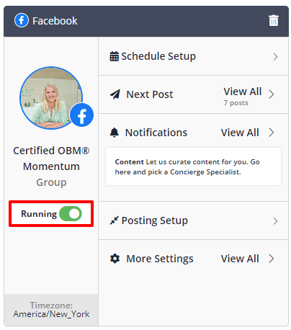

1. Go to “More Settings” then click “Reconnect”

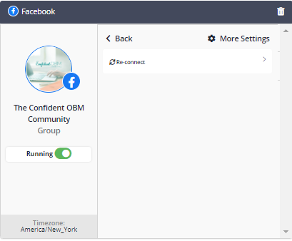

**Created by:**

**Department:** Operations & Support

**Date:**

**Revised:**

**Revised By:**